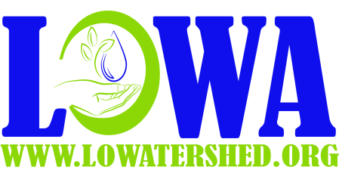
LOWA LIL’s Project 319 Application
Date:
Client Name:
Address and HUC:
Phone
Email:

Landscaper Name: |  |  |  |  | This is a  Do-it-Yourself Project
 | Total Estimate  of project eligible cost | LOWA Cost Share  40% or  Maximum of $2000 | Contractor Discount  10% or Max of $500 | Client Portion (=Total –LOWA Cost Share)  LOWA Member
Yes
No

Project Description:

Client Signature____________________________________________________________ Date___________________
LOWA APPROVAL SECTION
TVE Name ____________________________________________________________________
Notes on site Visit:

TVE signature ______________________________________________________________ Date________________

Approved Amount ___________________________________________________________________________________

LOWA Signature ____________________________________________________________ Date________________

LOWA Approval Printed Name ________________________________________________ Attachments Yes No
*US Environmental Protection Agency Region VII, through the Missouri Department of Natural Resources has provided partial funding for this project under section 319. of the Clean Water Act

